Michael Gross

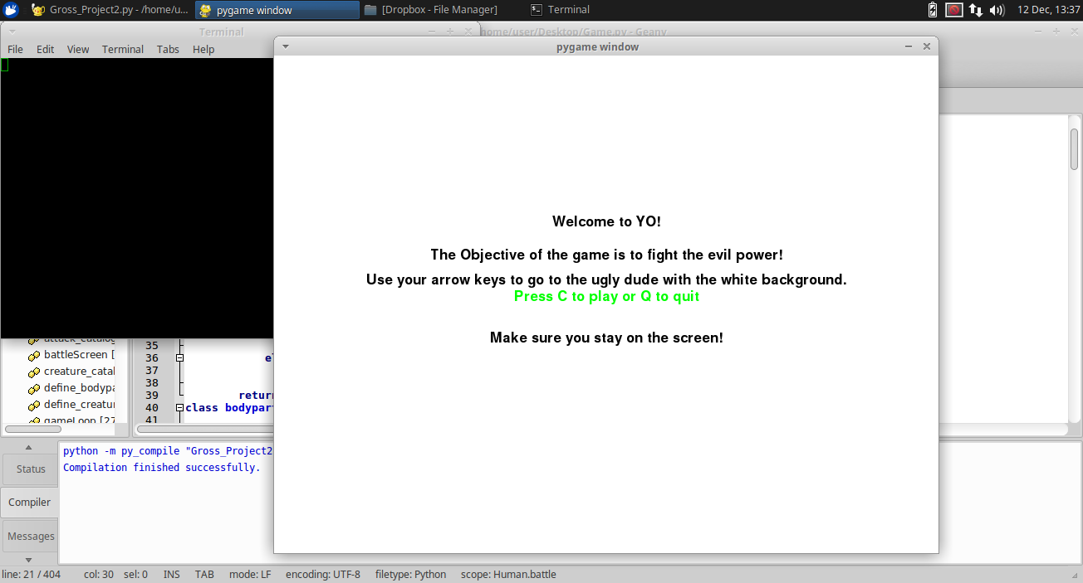

Hello and welcome to YO! The newest and best game to arrive to CU Boulder.

This document is written to provide an understanding of the code working in the game.

In order to use this you must import the pygame library.

We will split the code up like below and go in depth to understand each element

Classes

Global Variables

Functions

Main Loop

**Classes**

First and foremost, the real meat of the code is the classes. There are three classes that all have different functionality but form the main list of each other. For example, in class Human you have a creature list which holds the creatures in it. The creature class has a bodypartlist. The body parts hold values such as name, strength, and health. That list’s health values are then summed to form the overall strength and health of the creature itself. If a bodypart is removed from the list, then the overall health and strength will go down. The classes also have a battle function that will enter a creature or human into a battle scenario wherein the creature list will be decremented until there is none left and the battle scenario ends. The creature battle function also exists within the human battle function.

**Global Variables**

Global variables are variables used by all facets of the code at the same time and are best left untouched. This includes the colors used to animate fonts and backgrounds as well as the display width and height. Also the clock and fonts are set up here.

**Functions**

Some functions are used like define bodypart and creature using dictionaries as well as some other aesthetic functions like message to screen and an intro function. I will go through each functions abilities. The creature and attack catalog functions read a text file and turn it into a dictionary. There are two dictionaries that list the creature and in turn returns its bodypart list and that bodypart list is then checked against another dictionary that lists the strength and health values. The define bodypart and creature functions takes in whatever object and initialize its bodypart list and stats for each bodypart in the list giving a whole creature ready to enter into the battle functions that are inherent within the classes. The battlescreen is basically an event wherein if something calls it, a new screen appears and in the terminal a series of events takes place where the battle function from the Human class is used. Afterwards depending on the winner a new screen will appear showing if you lost or won.

The intro function is merely an intro screen.

**Main Loop**

The main game loop begins with a series of creatures being created and defined. They are then added to the creature list for the human. Two humans are created, Avi and Andy. I will detail who they are on the pygame screen soon enough. Some other variables exist within here which are shapes as well as some thickness parameters like block thickness and their location on the screen. The Frames Per Second is also its own variable. Some Boolean variables are also stated. gameExit actually exits the game but gameOver causes a gameOver screen that allows you to restart and play again. Within the game loop is a series of for event in pygame.event.get(): loops that are there to generate responses on the screen given certain KEYDOWN’s like K_LEFT makes the x component of our block to go the left. KEYUP is necessary also because that is also an event that triggers the change in the block to become 0 again.

Then an interesting if statement is present. If the block that we use goes into the boundaries of another block that we created using Apple Thickness and given random coordinates (randAppleX and randAppleY), and if the length of our creature lists are both over zero, then we can enter the above battle screen that in turn triggers the human battle function that calls on the creature battle function. At the end there are more gameDisplay functionality that calls the background sprite as well as blits the images loaded over the blocks generated so we have some fun sprites to look at!

Above is an intro screen. Below are some additional pictures of the game working.

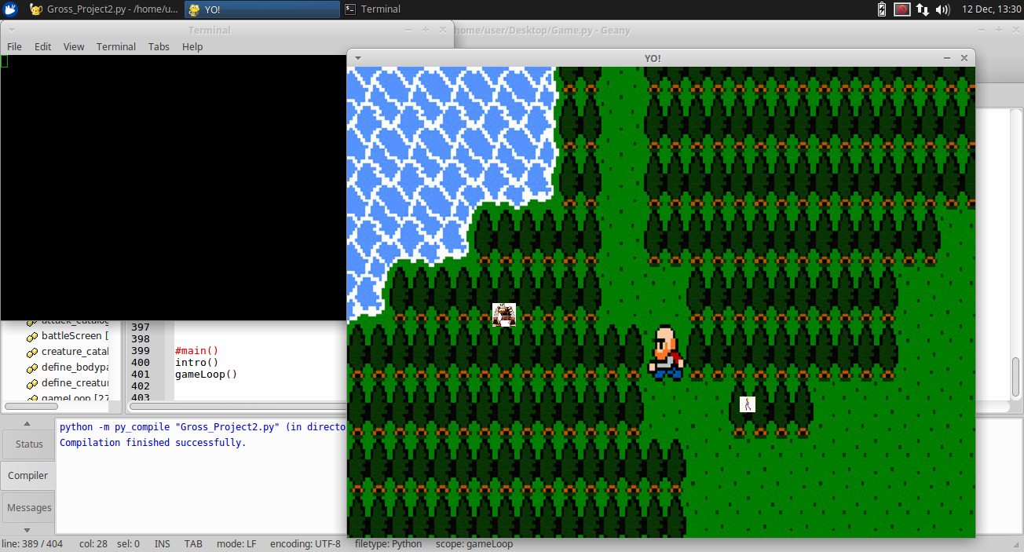

First screen of gameplay.

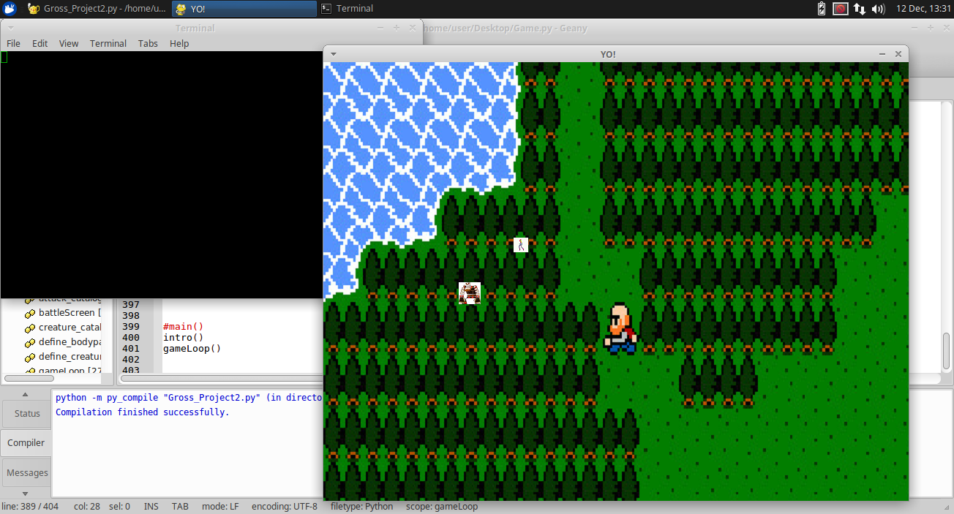

Compared to the first screen, this displays some movement of the little girl sprite.

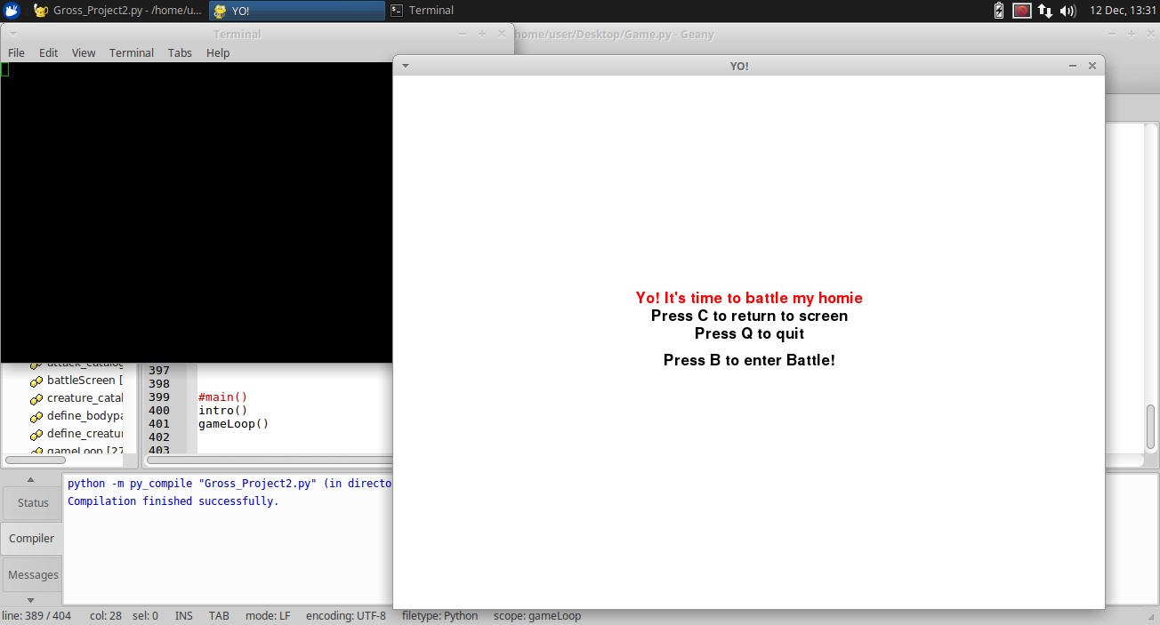

If you go over the big bad man then it enters the battle screen.

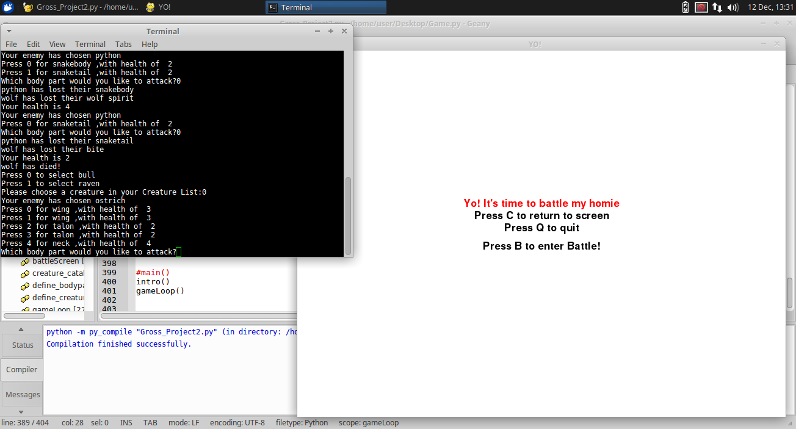

This shows the battle in action

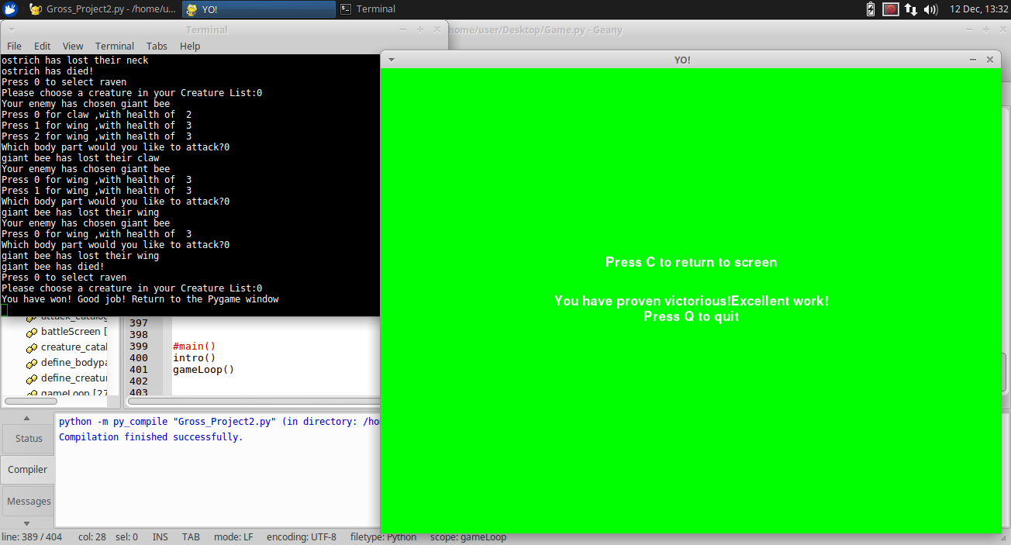

This shows if you win the battle

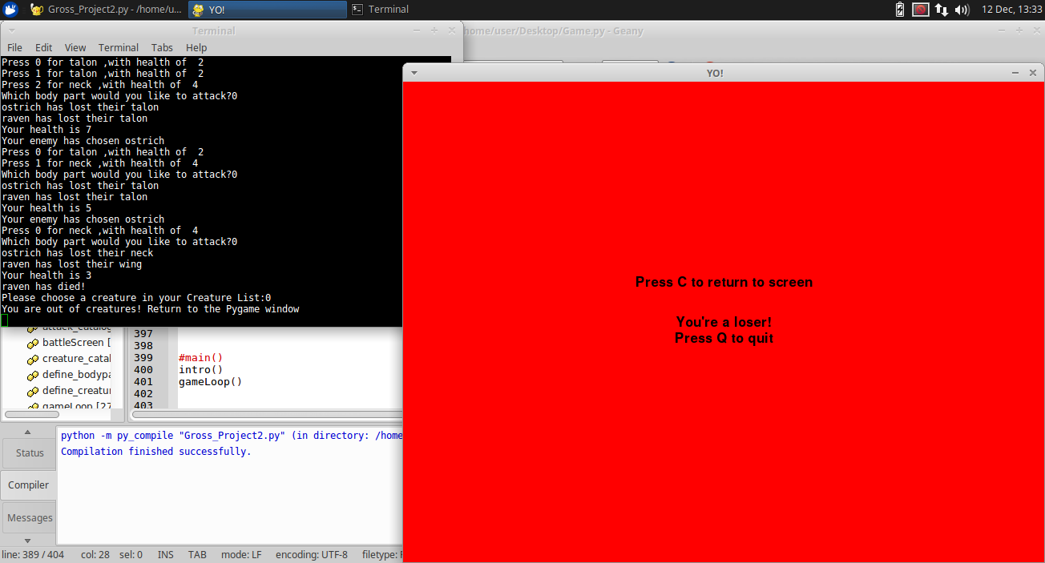

This shows if you lose the battle

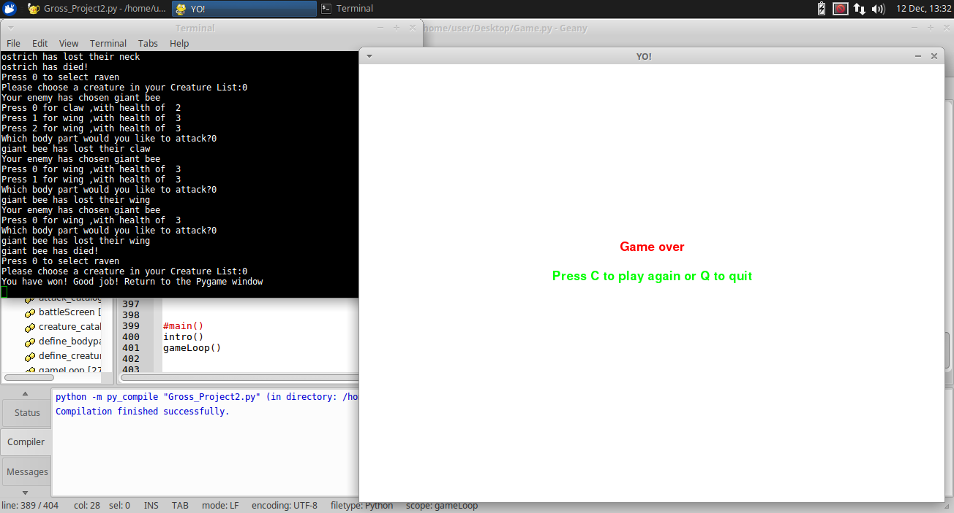

This screen gets displayed when you go off the screen.